**Endoscopy SMS Reminder Program by Simon Crouch**

**Overview**

The program I created takes in a CSV file of data from Cerner, interrogates the data to find people with a mobile number and an appointment of schedule in the future, then uses the free SMS service from NHS.net to send that patient a reminder.

As this model is a proof of concept for now, the CSV file will need to be created manually by a person in this current version. This means that the amount of days before an appointment date can be determined by the search that person does. Cerner does not allow data to be automatically extracted from its live database, so this will have to be performed manually through Explorer menu.

**Important note:** The free SMS NHS.net service is nationally provided by the Department of Health. However the funding has now been removed, and this service will end on 31 March 2015. North Bristol trust are currently working towards a replacement service funded by the trust.

**Instructions**

Insert your smartcard and typing your pin for Cerner Open Explorer Menu and go to the following report:

Main Menu > Custom Reports > Inpatient Reports > TCI dates for Daycase (then select Southmead Hospital, L3 Gate 13 Endo)

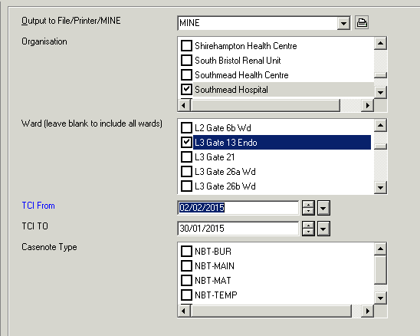

Execute the report.

Save the report to c:\SMS\SPFIT_TCI_DAYCASE.csv

(This will be faster if you copy and paste the following before the file name:   
\\Client\C$\Cerner Audit\

Go to the Start Menu and click SMS Follow the instructions.

**Manual backup process**

If anything ever happens to the program, this manual process will need to be done (which is what the program does):

* Insert your smartcard and typing your pin for Cerner Open Explorer Menu and go to the following report:
* Main Menu > Custom Reports > Inpatient Reports > TCI dates for Daycase (then select Southmead Hospital, L3 Gate 13 Endo)
* Execute the report
* Save the report to c:\SMS\SPFIT_TCI_DAYCASE.csv
* Open the report in Excel (the file will be located c:\SMS\SPFIT_TCI_DAYCASE.csv)
* Put a filter on the data Filter the data so that only patients with the mobile number are showing (Put on filter, on the mobile number, deselect the blanks in the filter) Filter so that only patients with a scheduled appointment are showing
* Log into [www.NHS.net](http://www.NHS.net) with your NHS.net email address and password
* Start a new message, ensure that the from address is changed to be the endoscopy main NHS.net email address
* Copy and paste the patients telephone number into the To field, append with @sms.nhs.net
* In the subject line (which is the content of the text message) type out (without quotes) "Reminder – your appointment is at " then insert the TCI date and time from the Excel document
* Send the message
* Repeat for every patient in the Excel document

**Further technical detail (not that you would want to read it!)**

We can't directly send programmatic email messages to the NHS.net service, as the SMTP address has been blocked by the trust, and the only way to unblock it would be to ask for a fixed IP address (which costs money).

The next option would be to have the email address link to your outlook account. However, this is only allowed to happen on encrypted machines like laptops. To do this on a desktop machine would require another license (which costs money) so that the folders can be encrypted.

The approach I have taken, is to emulate logging into the website programmatically. This is quite literally pretending to be a human logging into the webpage in order to send an email. Although this isn't the best approach, it is unlikely that the website will change as this is a nationally used website.

Hopefully, in time, the trust's replacement service will be accessible through its direct email SMTP address (which is the best option).

Lorenzo will have an SMS feature built into it, but it is uncertain whether the trust will have this ready for the time it takes on Lorenzo at the point of going Iive.

**Future**

To expand on this proof of concept, I would aim to incorporate the following features into the program:

* Logging all of the text messages SMS telephone numbers, date of sending, days before TCI date (done already) but so that
  + A) stats can be taken from the work
  + B) that patients are not sent two SMSes in one day
* Blocking a list of telephone numbers (in case patients specified they don't want to be contacted)
* Login to explorer menu, and selection patients automatically